***How to Update Awards and Decorations in MilPDS***

**Updating a New Award**

1. Sign into the MilPDS > Oracle application.
2. On the main Oracle screen, click the Customer Support folder > Career Enhancements > Awards and Decorations
3. Type in member’s full SSN or name (LAST, FIRST%) then hold Ctrl F11.
4. Ensure the appropriate member is highlighted and click Awards Decs.

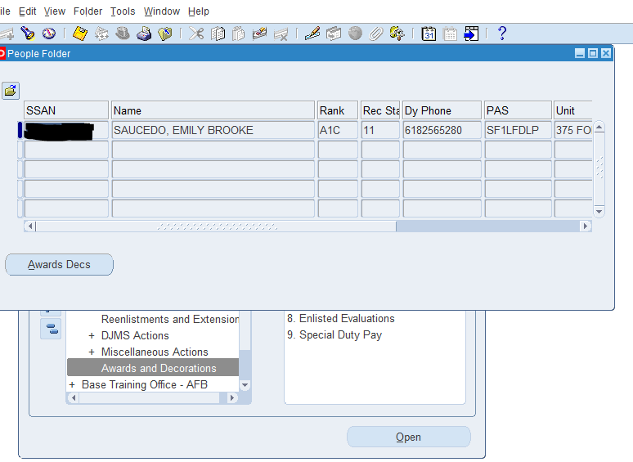

1. 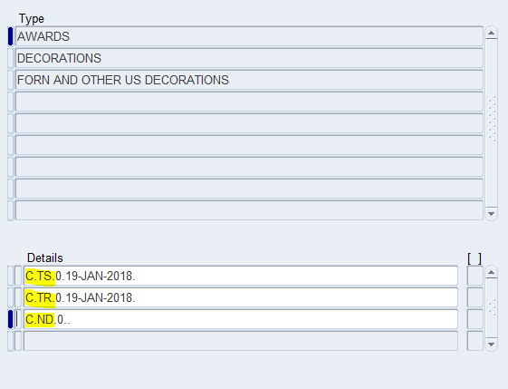When looking at the awards page, you should see the following codes:

These are the basic ribbons that are given to all Active Duty AF for completion of BMT or OTS. If you do not see these ribbons, add them. There is no supporting documentation or effective dates required for these ribbons ONLY.

1. To add a new award, click the “New” button (green + at top left corner of application) and click the next blank line.

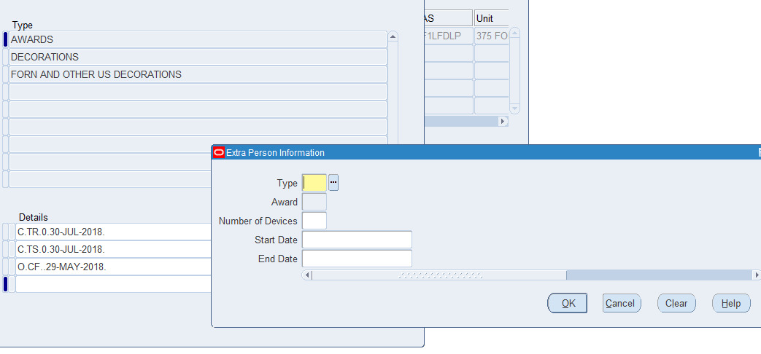

1. The “type” will be the category of award you are updating

* Campaign awards (most common)
* Foreign awards
* Non-Military awards
* Other awards
* State awards
* Unit awards

1. “Award” is the actual ribbon. Use the A/D listing or click the luv button to get the appropriate MilPDS code for the award you are trying to update.
2. “Number of Devices” should be 0 if this is the first time they are being awarded this ribbon.
3. “Start” and “End” dates are the effective dates of the ribbon.
4. Once all of the info is filled, click “OK” and “Save”
5. The member’s record is updated.

**Updating an Existing Award**

1. Repeat steps 1-5 from above.
2. If you are trying to update an award that the member already has, click on the line for the appropriate award.
3. The boxes will already be filled in.
4. Change “Number of Devices” to the next available number (ex: if it says 0, change it to 1)
5. Change the start and end dates to the most recent award of this ribbon.

Updating a Decoration

1. Click “Decorations” as shown below:

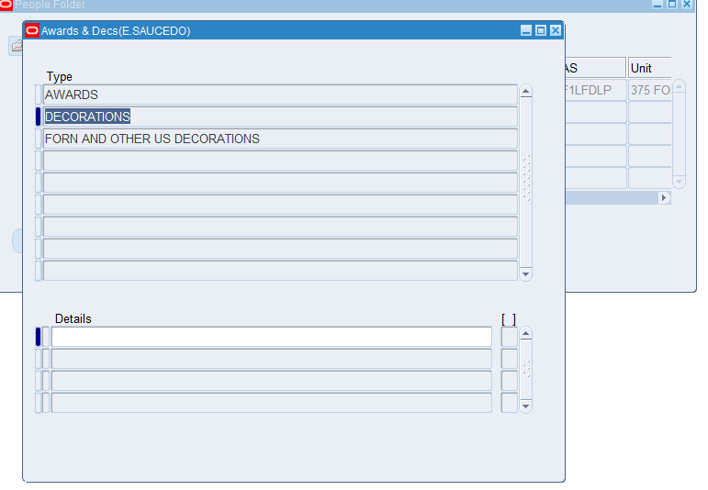

1. Click the first available blank space.
2. Fill in the boxes appropriately with information from the decoration.

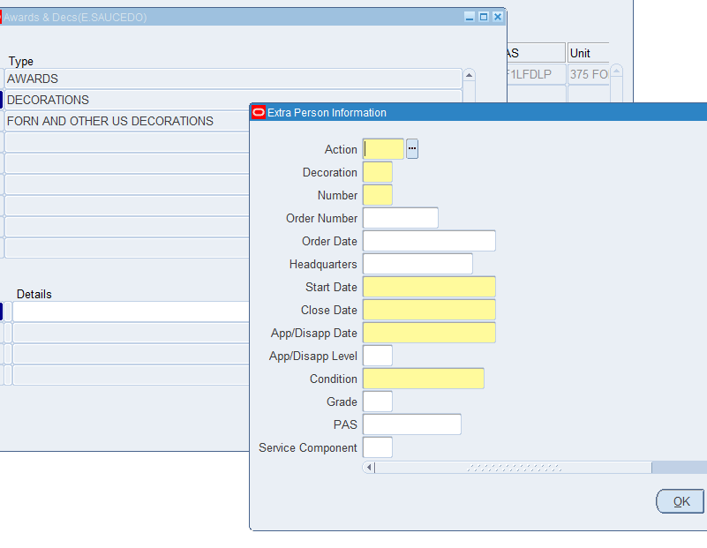

1. “Action” will be ADD.
2. “Decoration” is the type of Decoration (MilPDS codes found on listing or luv button).
3. “Number” will be 1 if it is their first of this type of decoration.
4. “Order Number” can be found on either the decoration itself or on the documents attached to it. Fill in numbers only. (ex: G-123456)
5. “Order Date” is the “Given Under my Hand” date.
6. If you don’t have the HQ info, leave that box blank.
7. Start and Close date will be the awarded period (found on the decoration).
8. “App/Disapp Date” is the same as the Order Date.
9. “App/Disapp Level” – leave it blank.
10. “Condition” will be the number most likely at the bottom next to the Order Number (1-8). This represents what they were awarded the decoration for (PCS, Separation, Extended Tour, etc.)
11. “Grade” is the member’s grade. Use 3 for enlisted members and 0 for officers. (Ex: SrA =34, Maj = 04)
12. “PAS” – Fill it in if you have it, leave it blank if not.
13. “Service Component” – R
14. Click “OK”
15. Save.

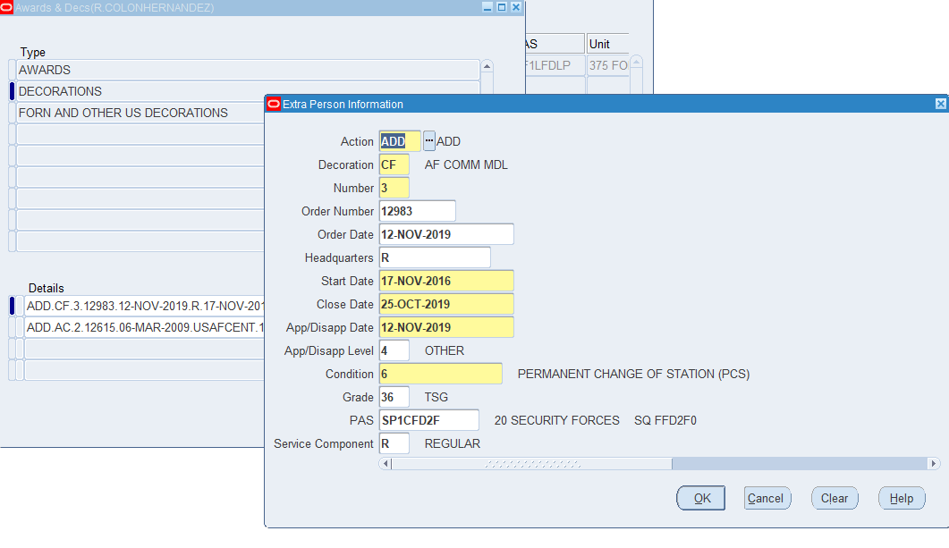

**Updating an existing Decoration**

1. Click on the appropriate space for the decoration you are trying to update.
2. Change “Number” to the next available number.
3. Change all of the other info including the order number, dates, and grade.
4. Click “OK”
5. Save.
6. The member’s record is updated.

**Deleting a Decoration**

1. Change Action to Downgrade.
2. Change Number to one number lower than it is. 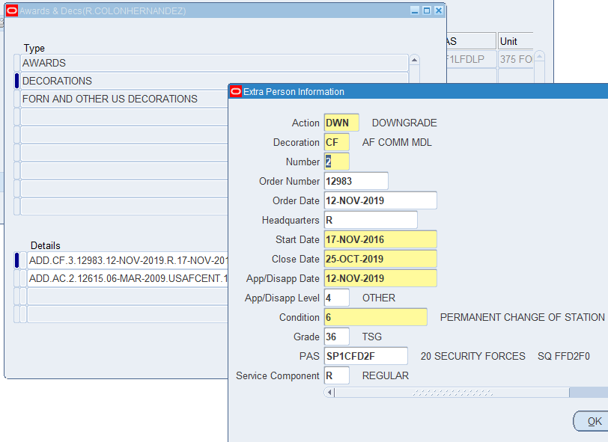
3. “OK”
4. Save.
5. Repeat this process until number says 0.
6. Change Action to Withdrawal. 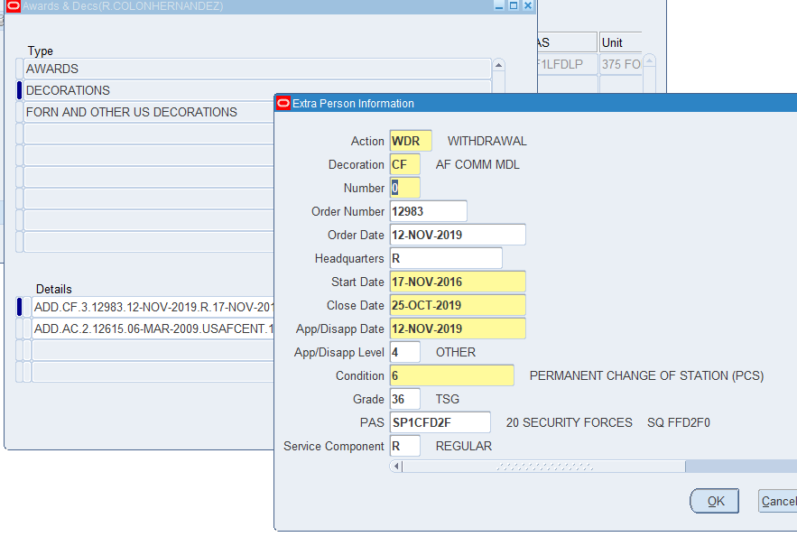
7. “OK”
8. Click “Delete” instead of save.
9. “YES”
10. Save.